Create the Agent and add the required API keys in API request to fetch the story from Jira
Add the required prompt in prompt template
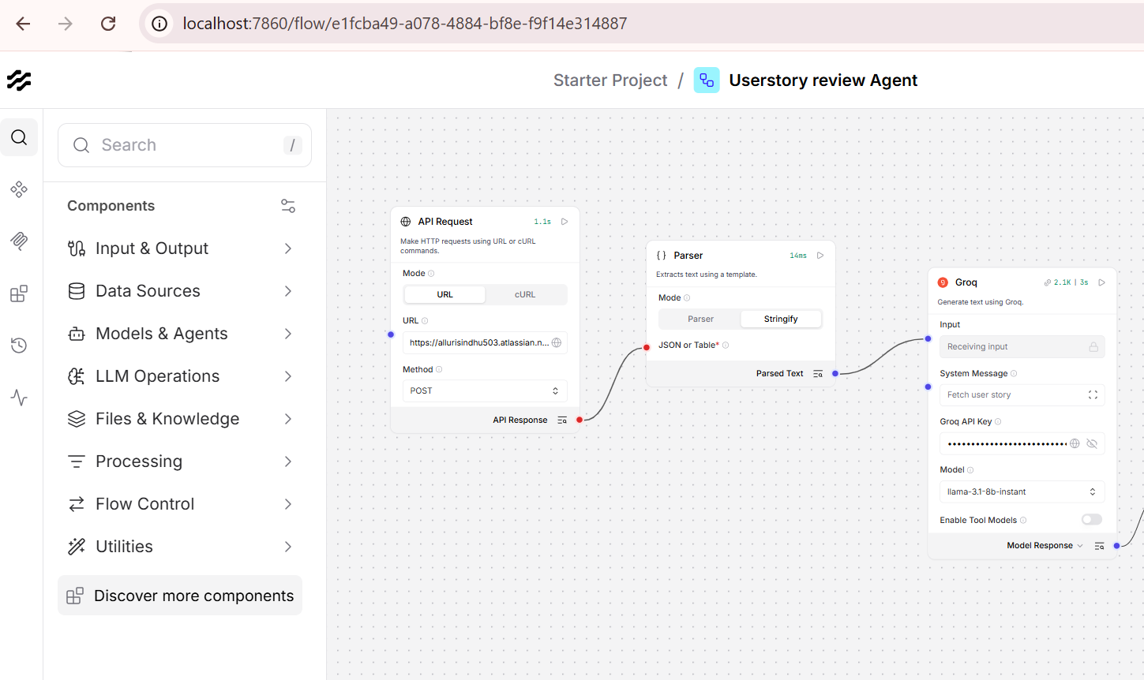

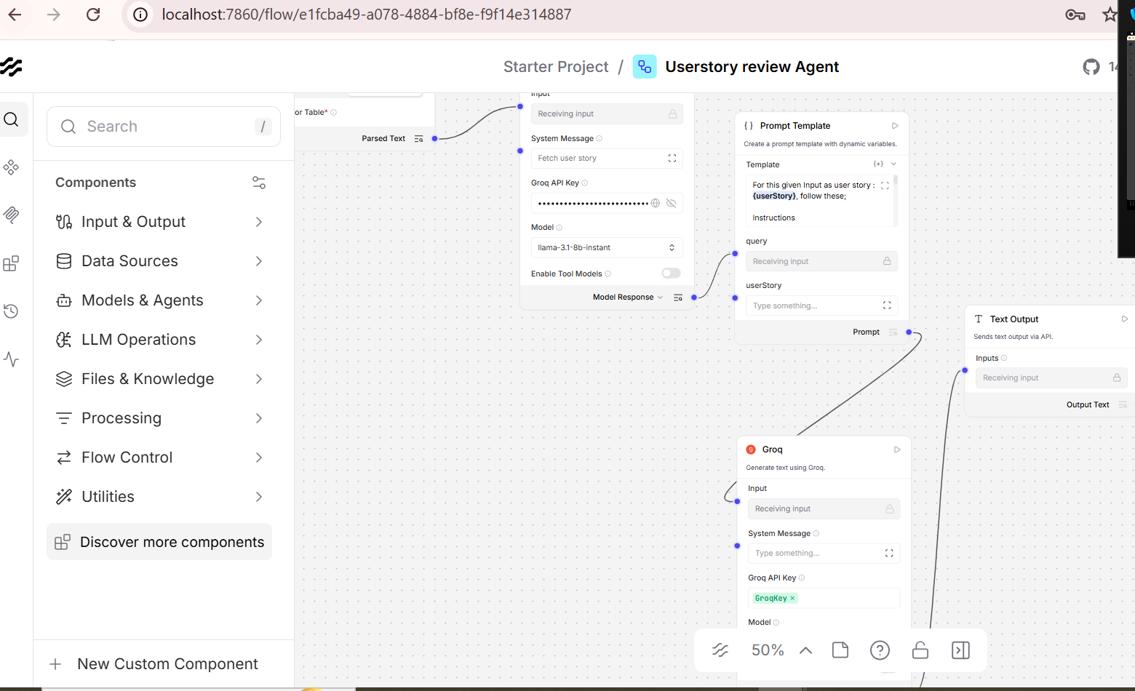
Input :
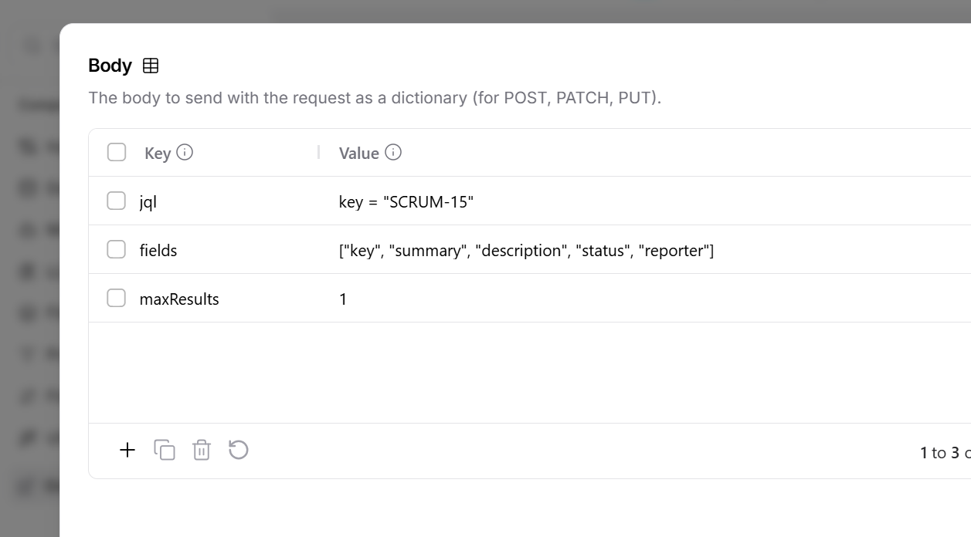

Output :
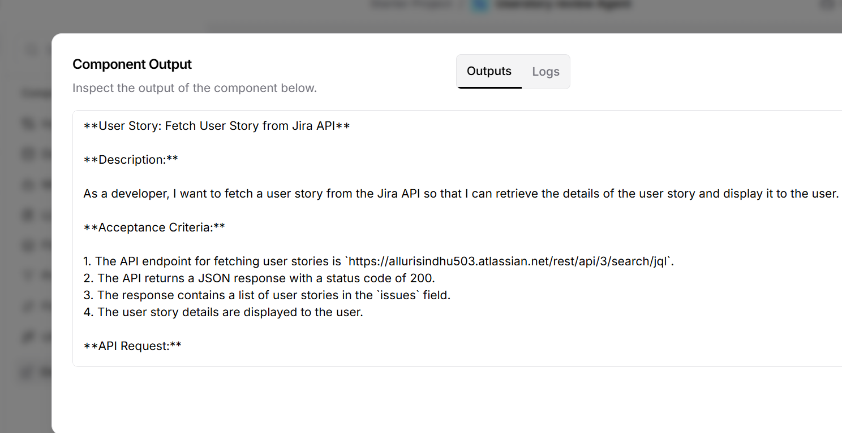
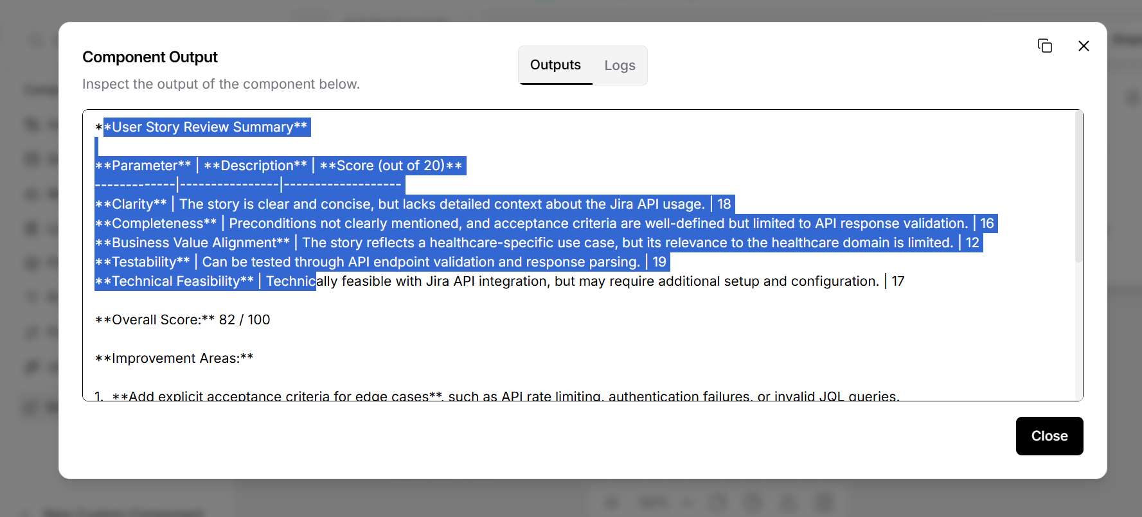

Raw output
**User Story Review Summary**

**Parameter** | **Description** | **Score (out of 20)**
-------------|----------------|-------------------
**Clarity** | The story is clear and concise, but lacks detailed context about the Jira API usage. | 18
**Completeness** | Preconditions not clearly mentioned, and acceptance criteria are well-defined but limited to API response validation. | 16
**Business Value Alignment** | The story reflects a healthcare-specific use case, but its relevance to the healthcare domain is limited. | 12
**Testability** | Can be tested through API endpoint validation and response parsing. | 19
**Technical Feasibility** | Technically feasible with Jira API integration, but may require additional setup and configuration. | 17

**Overall Score:** 82 / 100

**Improvement Areas:**

1. **Add explicit acceptance criteria for edge cases**, such as API rate limiting, authentication failures, or invalid JQL queries.
2. **Specify validation rules for API response fields**, including expected data types and formats.
3. **Include system actor details for API authentication and authorization**.
4. **Provide more context about the Jira API usage**, including the purpose of fetching user stories and the expected outcomes.
5. **Consider adding a use case for error handling and exception management**.

**Recommendations:**

* To improve the story's clarity, consider adding a brief description of the Jira API and its usage in the healthcare domain.
* To enhance completeness, specify preconditions for API authentication and authorization, and add acceptance criteria for edge cases.
* To increase business value alignment, consider rephrasing the story to focus on a healthcare-specific use case, such as fetching user stories for clinical workflow automation.
* To improve testability, consider adding test cases for API endpoint validation and response parsing.
* To enhance technical feasibility, consider providing more details about the Jira API integration and setup requirements.

